***A myriad things go according***

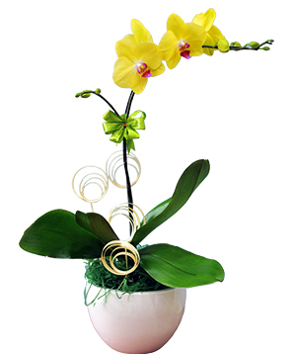

*White Phalaenopsis orchid is always a luxurious gift for each other in the coming New Year and spring. The meaning of white Phalaenopsis orchid is for a good start, perfect success. It will be a very meaningful spring gift or a very meaningful congratulatory gift to give to relatives, friends, partners or customers.*